The following instructions are designed to assist CC agencies in writing and submitting CalFresh Outreach Success Stories for sharing with stakeholders, in reports, newsletters, on social media, etc.

For this reason, CCC is looking for well-written success stories that highlight your program’s successes.

Please follow all 8 steps and instructions below, **completing your story within this template** and submitting it to CCC.

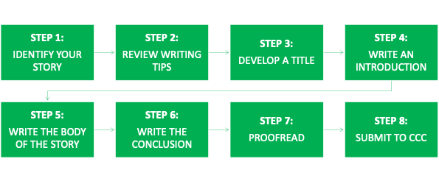

|  |
| --- |
| **STEP 1:** IDENTIFY YOUR STORY |
| The purpose of a CalFresh Outreach success story is to document and highlight how your CalFresh Outreach program successfully connects eligible clients with CalFresh Food. Stories can either focus on highlighting CFO programming successes, or on an individual client success story.  For your story, choose whether you will be writing a story about:   * Aspects of your overall CFO programming, such as successes with any partnerships developed, successfully reaching a new target population, new outreach events and strategies, etc.; or * An individual client’s success story about how your program assisted them in successfully obtaining CalFresh for themselves and/or their household |
|  |

|  |
| --- |
| **Step 2:** REVIEW THE WRITING TIPS |
| Review the following writing tips before beginning to draft your story:   * Please do not include a client’s name or any other identifying information about a client. * Use good grammar and check for spelling and typing errors. * Use short sentences and paragraphs, bulleted lists, and succinct writing. * Avoid jargon. * When using an acronym for the first time, spell out the full name followed by the acronym in parenthesis¸ e.g. Catholic Charities of California (CCC) * Use the active voice instead of passive voice. Instead of: The story was written by Bob. Try: Bob wrote the story. * Write your story for a non-technical person who has never heard of the program. |
|  |
| **STEP 3**: CREATE A CLEAR AND EFFECTIVE TITLE |
| Provide a short, clear and effective title that will grabs reader’s attention. Consider the following:   * Provide context for the story and include the who/what/where * Use action words in the present tense * Focus on the solution – not the problem   **Enter your title here** |
|  |
| **STEP 4:** WRITE THE INTRODUCTION |
| Provide a paragraph that starts with a brief description of your agency and your CFO program.  **For program success stories**, consider the following prompts as you write your story’s introduction:   * What was the need or challenge that your program was addressing? * Describe the target population, geographic area, and use any data to support the need for food assistance in this area.   **For client success stories**, consider the following prompts as you write your story’s introduction:   * How did the client get connected to your agency? * What was their situation like before coming to the agency? * Why did they seek your agency’s services? * Does the family include any special populations (homeless, senior, student, etc)?   **Enter your introduction paragraph here** |
|  |
| **STEP 5:** WRITE THE BODY OF YOUR STORY |
| **For program success stories**, include details about the specific work done and highlight any partnerships developed. Consider the following prompts as you write the body of your story:   * What work was done by your CFO program to address the need/challenge. * Describe any challenges/barriers encountered with the work and how your program addressed these challenges.What was the outcome of your efforts?   **For client success stories**, include details about the process of supporting the client through the application process. Consider the following prompts as you write the body of your story:   * How did you support the client/county during the application process? * Describe any challenges/barriers encountered during the application process with the County office and how you were able to get these resolved for the client. * What was the outcome of the application?   **Enter the body of your story here** |
|  |
| **STEP 6:** WRITE THE CONCLUSION |
| **For program success stories**, write a paragraph summarizing the impact of the work. Consider the following prompts as you write the body of your story:   * Why was the work successful? * Provide any data/details to demonstrate that the effort was successful (number of people reached, number of applications submitted/approved, etc.) * Describe any next steps or future work planned.   **For client success stories**, write a paragraph summarizing the benefit to the client. Consider the following prompts as you write the concluding paragraph:   * How did the outcome of your efforts benefit the client? * Were any other family members or community members impacted by the outcome in a positive way? * Was the client referred to any others agency services? * How do you plan to follow-up with the client to support them in the future? * Optional: Include a quote from the client.   **Enter the conclusion of your story here** |
|  |
| **STEP 7:** PROOFREAD |
| Please review your writing style and the content again based on the writing tips included in Step 2. Be sure to use Microsoft Word’s spelling and grammar feature to make corrections prior to finalizing the text. |
|  |
| **STEP 8:** SUBMIT TO CCC WITH SUPPORTING PHOTOS |
| Once you have completed entering your story into this form, [**email it to CCC program staff.**](mailto:natalie@catholiccharitiesca.org?subject=Completed%20Success%20Story%20Template) **Please include any supporting photos.** |
|  |